
COIT20258 Software Engineering
Assessment 2: DRS-Initial Prototype
Research Report

Student Name: Jerald Christopher Bucud
Student ID: 12301099
Unit Coordinator, Lecturer, Tutor: Meiru Che

Contents
Section 1. Introduction 3
Section 2. Revised Requirements Summary 4
Section 3. UML Class Diagram 5
3.1 UML Class Diagram 5
3.2 UML Diagram Explanation 6
Section 4. Test Plan 7
4.2 Test Plan 8
4.3 Test Evidence Screenshots 10
Section 5. Reflection 31

Section 1. Introduction
The Disaster Response System Initial Prototype (DRS-Initial) was developed for COIT20258 Assessment 2. This report focuses on the required report components: the detailed UML class diagram, the test plan, and the reflection on requirements, user interface design, and implementation.
DRS-Initial continues from the Assessment 1 requirements specification. The original Disaster Response System was reviewed and reduced into an initial prototype scope for Assessment 2. The prototype focuses on the main disaster response workflow, including disaster reporting, incident validation, severity assessment, response prioritisation, emergency response dispatch, and incident status updates.
NetBeans, JavaFX, Scene Builder, and JUnit 4. were used in developing the prototype for the Disaster Response System. The user interface, model classes, controller logic, service logic and data storage follows the pattern of Model View Controller to separate each parts. Seeded sample data and in-memory storage were used instead of a database, since the purpose of the prototype is to demonstrate and test the main functions of DRS-Initial.
Two creative features are also introduced in this prototype, The Emergency Resource Availability Tracker and the Incident Search and Filter feature. These features provide faster response decision making by helping users check resource availability and locate incident records.
This report contains the final UML class diagram, test plan with test data and expected results and a reflection on the amended requirements definition, user interface design and implementation. This is in line with Assessment 2 report criteria for UML class diagrams, test planning and reflection.

Section 2. Revised Requirements Summary

The Assessment 1 requirements specification was reviewed and reduced for Assessment 2. The original Disaster Response System described a wider disaster management system with many response, recovery, monitoring, and administration functions. Regarding DRS-Initial, the scope was refined to the functions implemented in the JavaFX prototype.
The revised prototype concentrates on the core disaster response workflow. This involves submitting a disaster report, validating and registering incidents, This scope supports the Assessment 2 requirement to revise the requirements specification, develop UML class diagrams, prepare a test plan, and implement the software prototype.
The revised use cases implemented in DRS-Initial are:
UCA2-UC1: Report Disaster
UCA2-UC2: Validate/Register Incident
UCA2-UC3: Assess Severity
UCA2-UC4: Prioritize Response
UCA2-UC6: Dispatch Emergency Response
UCA2-UC12: Update Incident Status
The revised use cases were used to identify the main classes, attributes, relationships, user inputs, and data stored in the prototype. They also guided the test plan by linking system behaviour to test data and expected results.
The detailed revised use case descriptions are included in Appendix A. The revised use case diagram is included in Appendix B.

Section 3. UML Class Diagram

3.1 UML Class Diagram
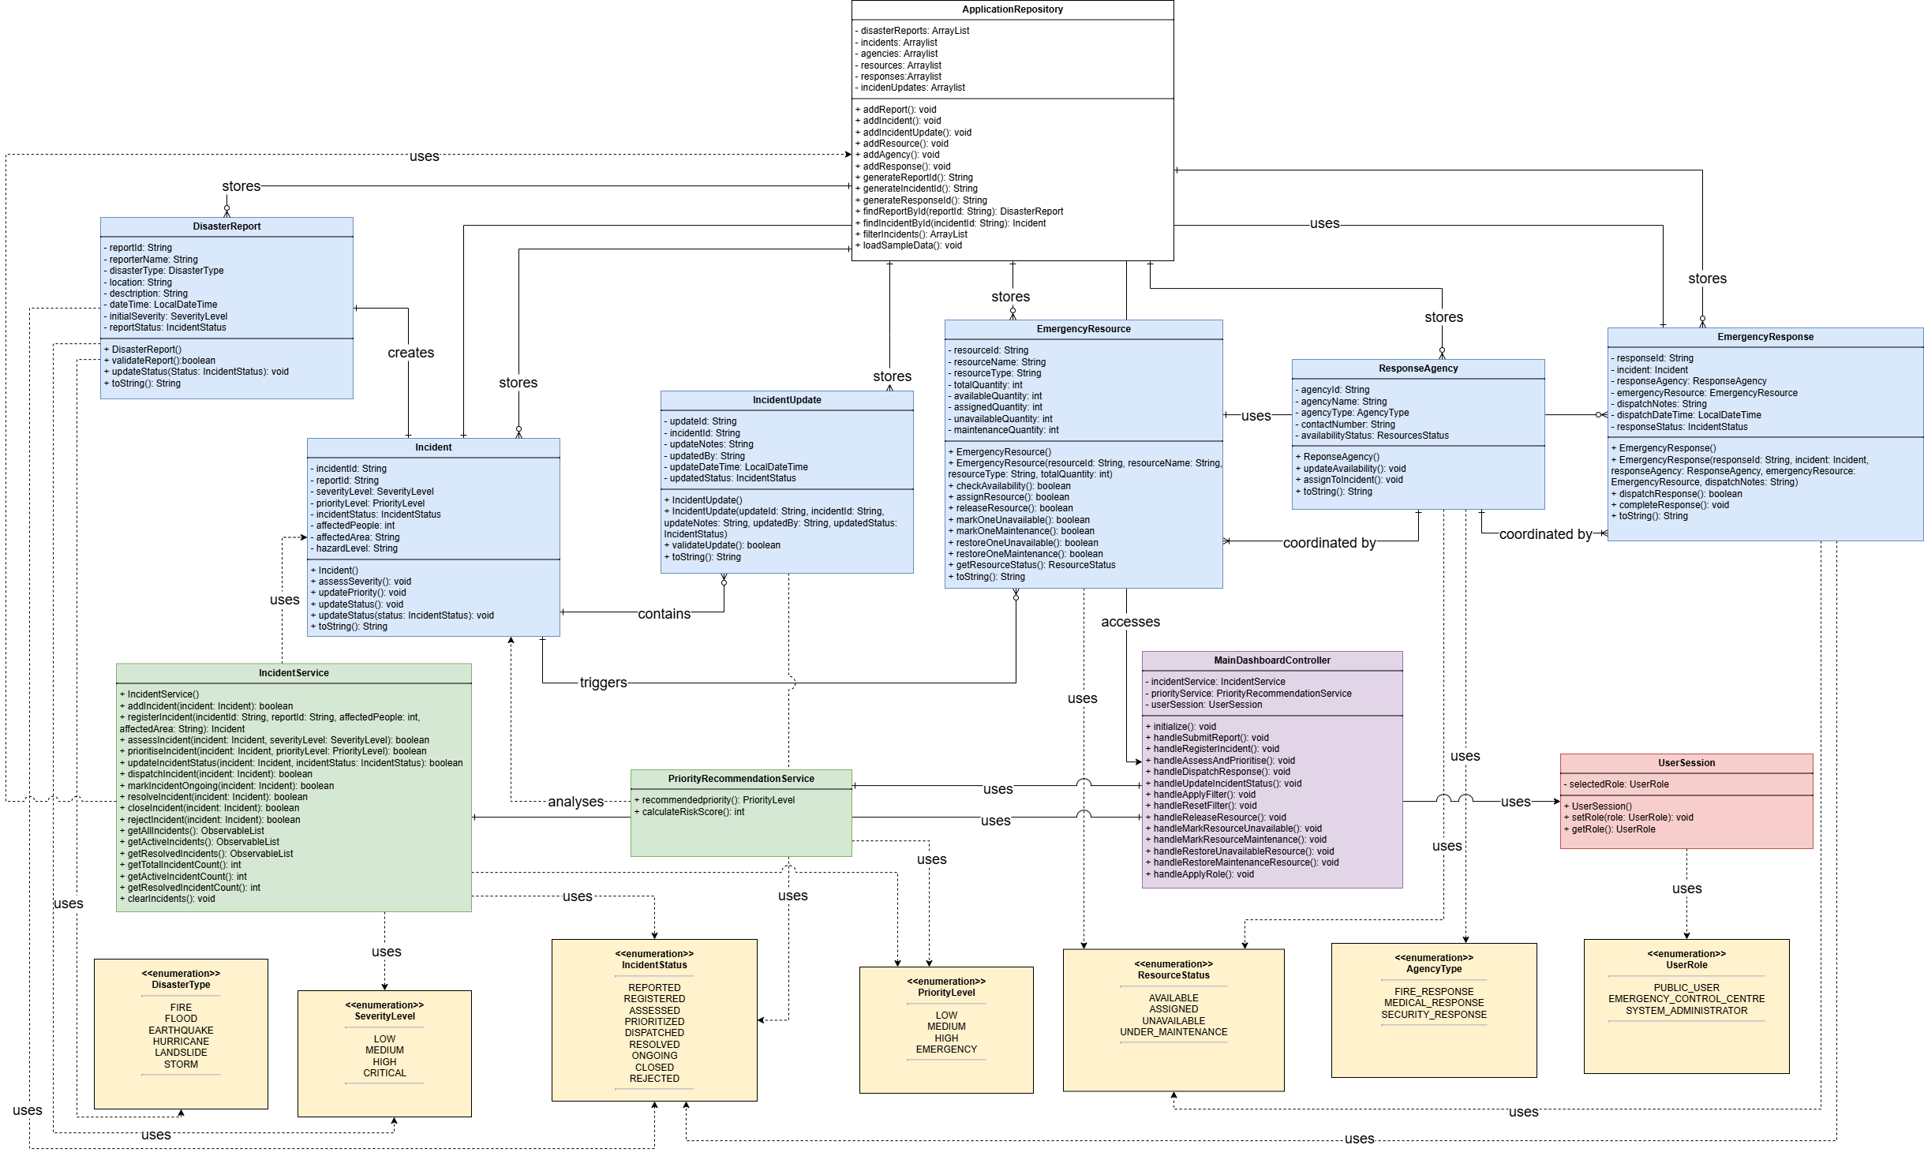
Figure 1: DRS-Initial UML Class Diagram

3.2 UML Diagram Explanation
The main structure of the DRS-Initial prototype is presented in Figure 1 using a UML class diagram. It shows the classes, attributes, methods, data types, associations and cardinalities needed to enable the implemented disaster response workflow. This satisfies the Assessment 2 requirements for a detailed UML Class diagram, including attributes, methods, data types and associations.
The model layer is composed of the core system data classes: DisasterReport, Incident, EmergencyResponse, EmergencyResource, ResponseAgency and IncidentUpdate. These classes are the main records utilized in the prototype.
DisasterReport stores submitted disaster report details. Incident stores validated incident information, including severity, priority, status, affected people, affected area, and hazard level. EmergencyResponse links an incident with a response agency and an emergency resource. EmergencyResource stores resource details and availability status. ResponseAgency stores agency details and availability status. IncidentUpdate stores update notes and status changes for an incident.
The diagram also comprises ApplicationRepository, IncidentService, PriorityRecommendationService, MainDashboardController and UserSession. ApplicationRepository contains the seeded sample data and in-memory lists for reports, incidents, agencies, resources, responses, and incident updates. IncidentService handles incident related operations such as incident registration, severity assessment, incident prioritisation, response dispatching, status updating and incident filtering. The PriorityRecommendationService proposes a priority level based on the incident facts. The MainDashboardController is the link between the JavaFX interface and the model, service, repository and session classes. UserSession holds the selected user role in runtime.
The UML diagram includes enumeration classes for fixed system values. These are DisasterType, SeverityLevel, PriorityLevel, IncidentStatus, ResourceStatus, AgencyType, and UserRole. These enumerations help keep system data consistent and reduce invalid values in the prototype.
The associations show how the main classes work together. A DisasterReport is used to create an Incident after validation. An Incident may have IncidentUpdate records and may trigger an EmergencyResponse. An EmergencyResponse is linked to one ResponseAgency and one EmergencyResource. The repository stores the main records used by the prototype. Overall, the UML diagram supports the MVC design and shows how the implemented classes connect to the revised Assessment 2 requirements.

Section 4. Test Plan

The test plan was developed to verify the main DRS-Initial workflow, the two selected creative features, and the core Java logic used in the prototype. The Assessment 2 specification requires a test plan showing test data and expected results, so each test case includes the tested requirement or feature, test data, expected result, actual result, and status.
Manual testing was used to verify the JavaFX graphical user interface and user workflow. JUnit 4 testing was used to verify model, service, repository, session, emergency response, emergency resource, and priority recommendation logic. This combination checks both the user-facing prototype and the underlying Java classes.

4.2 Test Plan
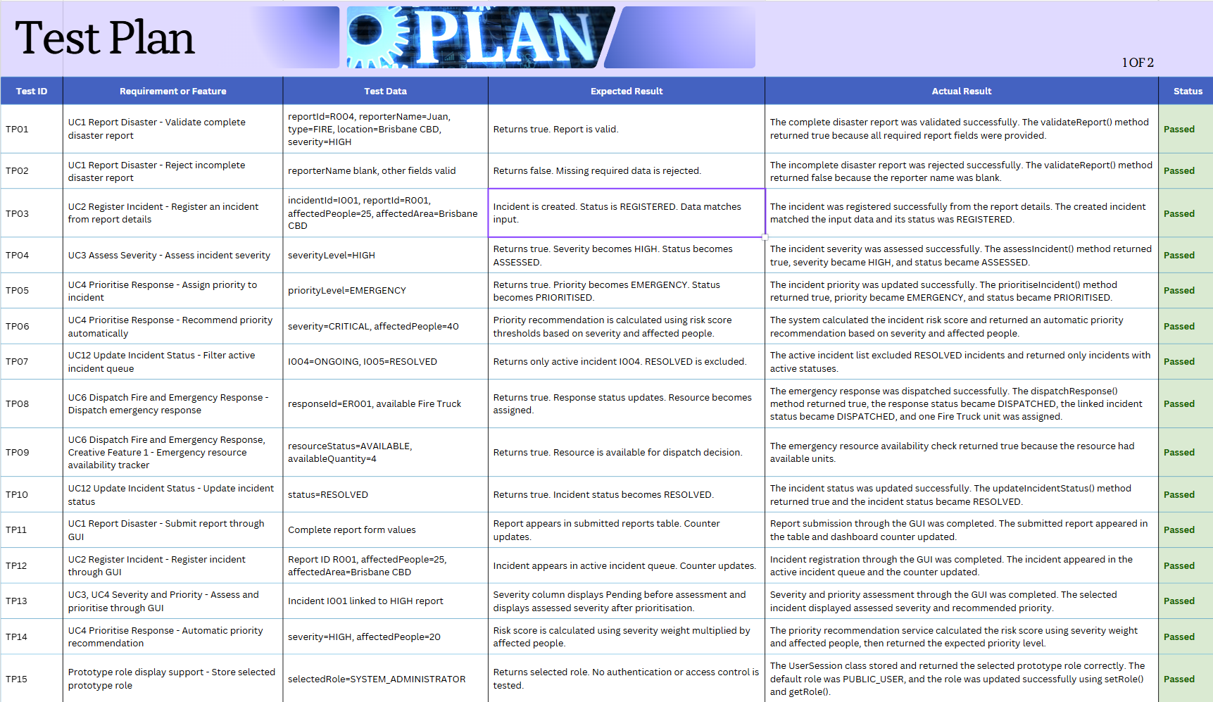
Table 1: DRS-Initial Test Plan

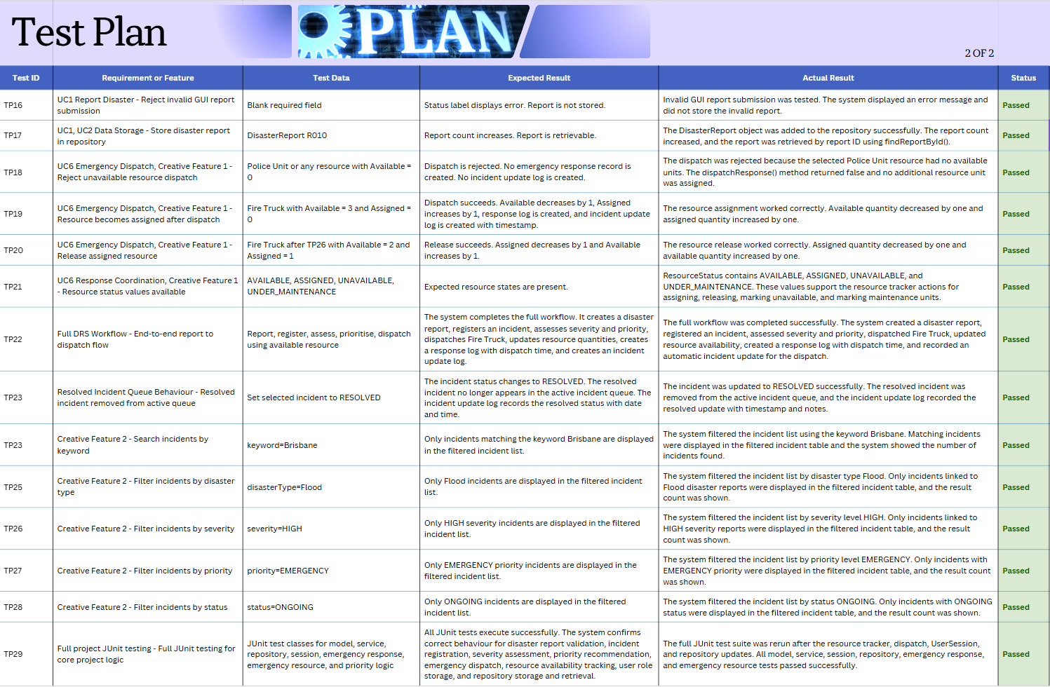

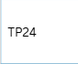

4.3 Test Evidence Screenshots
The screenshots for the completed tests are included in this section as evidence of execution.
TP01 and TP02
Figure 2: Disaster Report Test Evidence 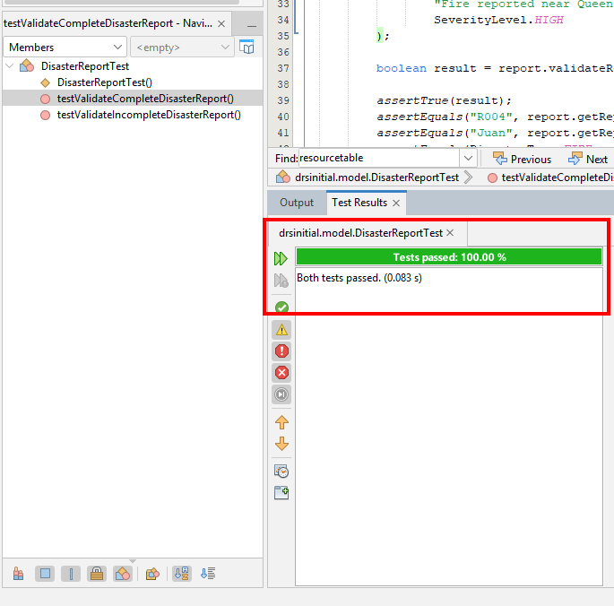

TP03, TP04, TP05, TP07, and TP10
Figure 3: Incident Service Test Evidence
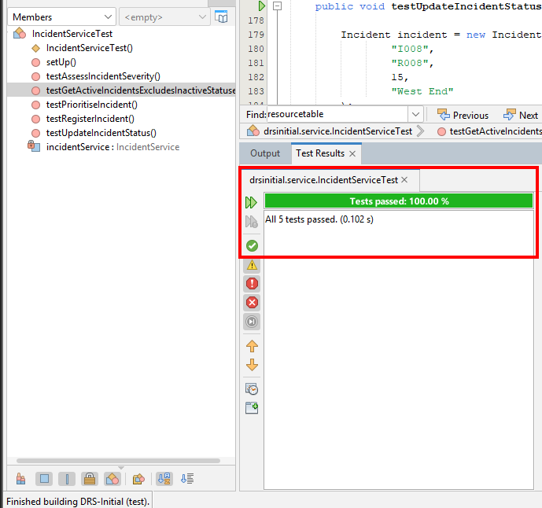

TP06 and TP14
Figure 4: Priority Recommendation Service Test Evidence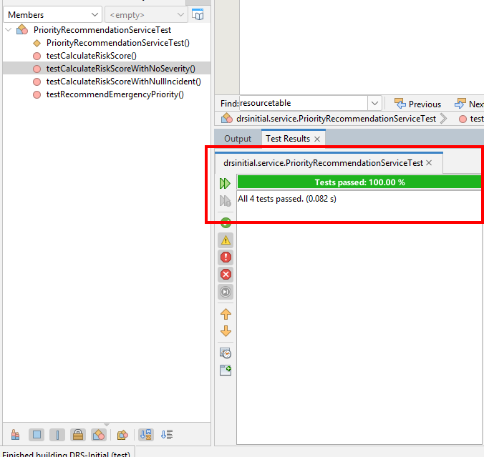

TP08 and TP18
Figure 5: Emergency Response Test Evidence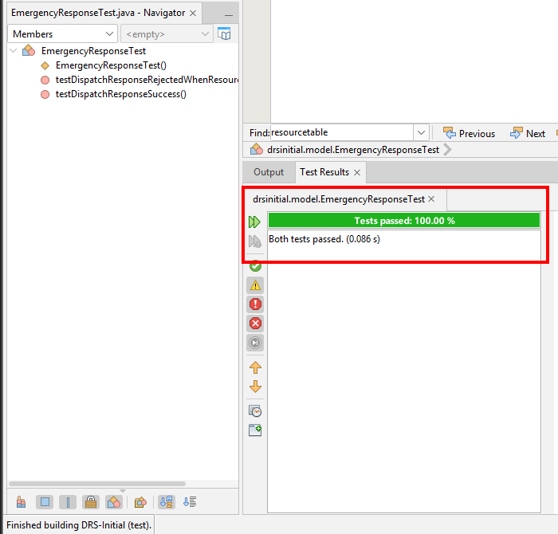

TP09 and TP19
Figure 6: Emergency Resource Test Evidence
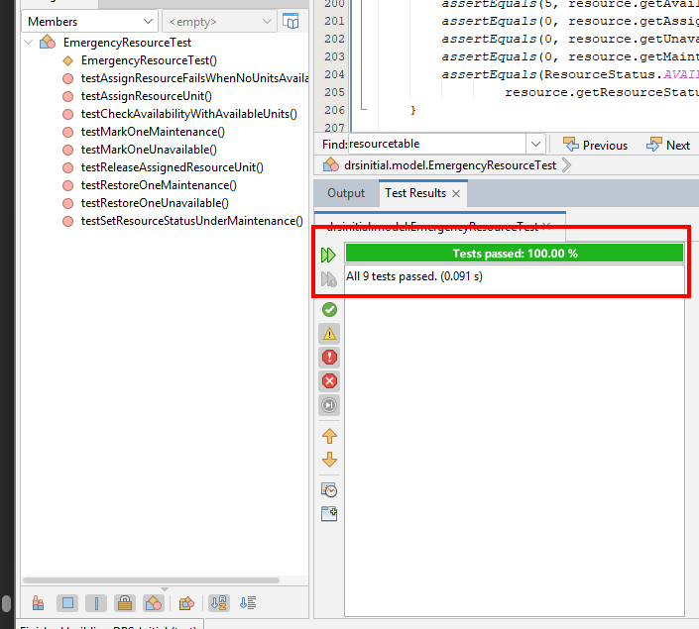

TP15
Figure 7: User Session Test Evidence
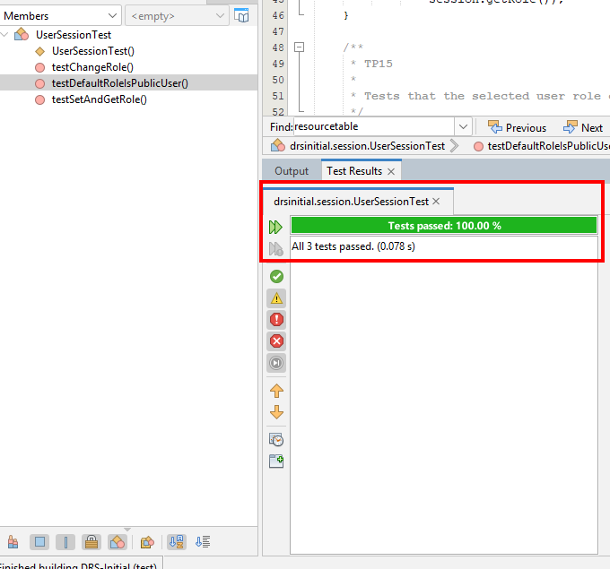

TP17
Figure 8: Application Repository Test Evidence
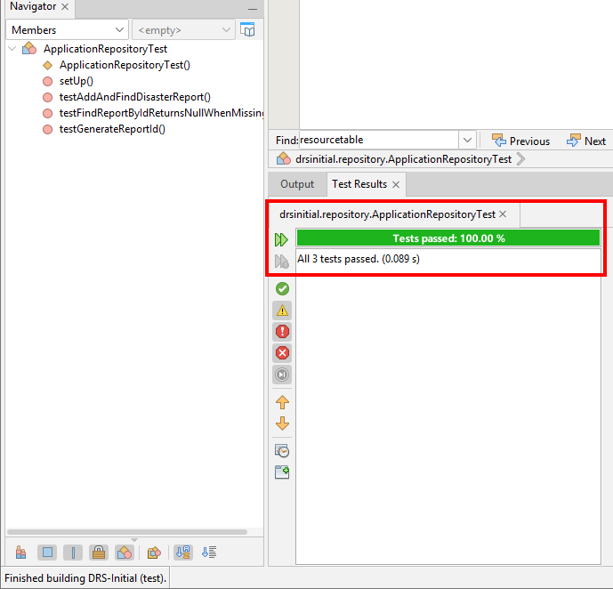

TP20
Figure 9: FireTruck Before Release
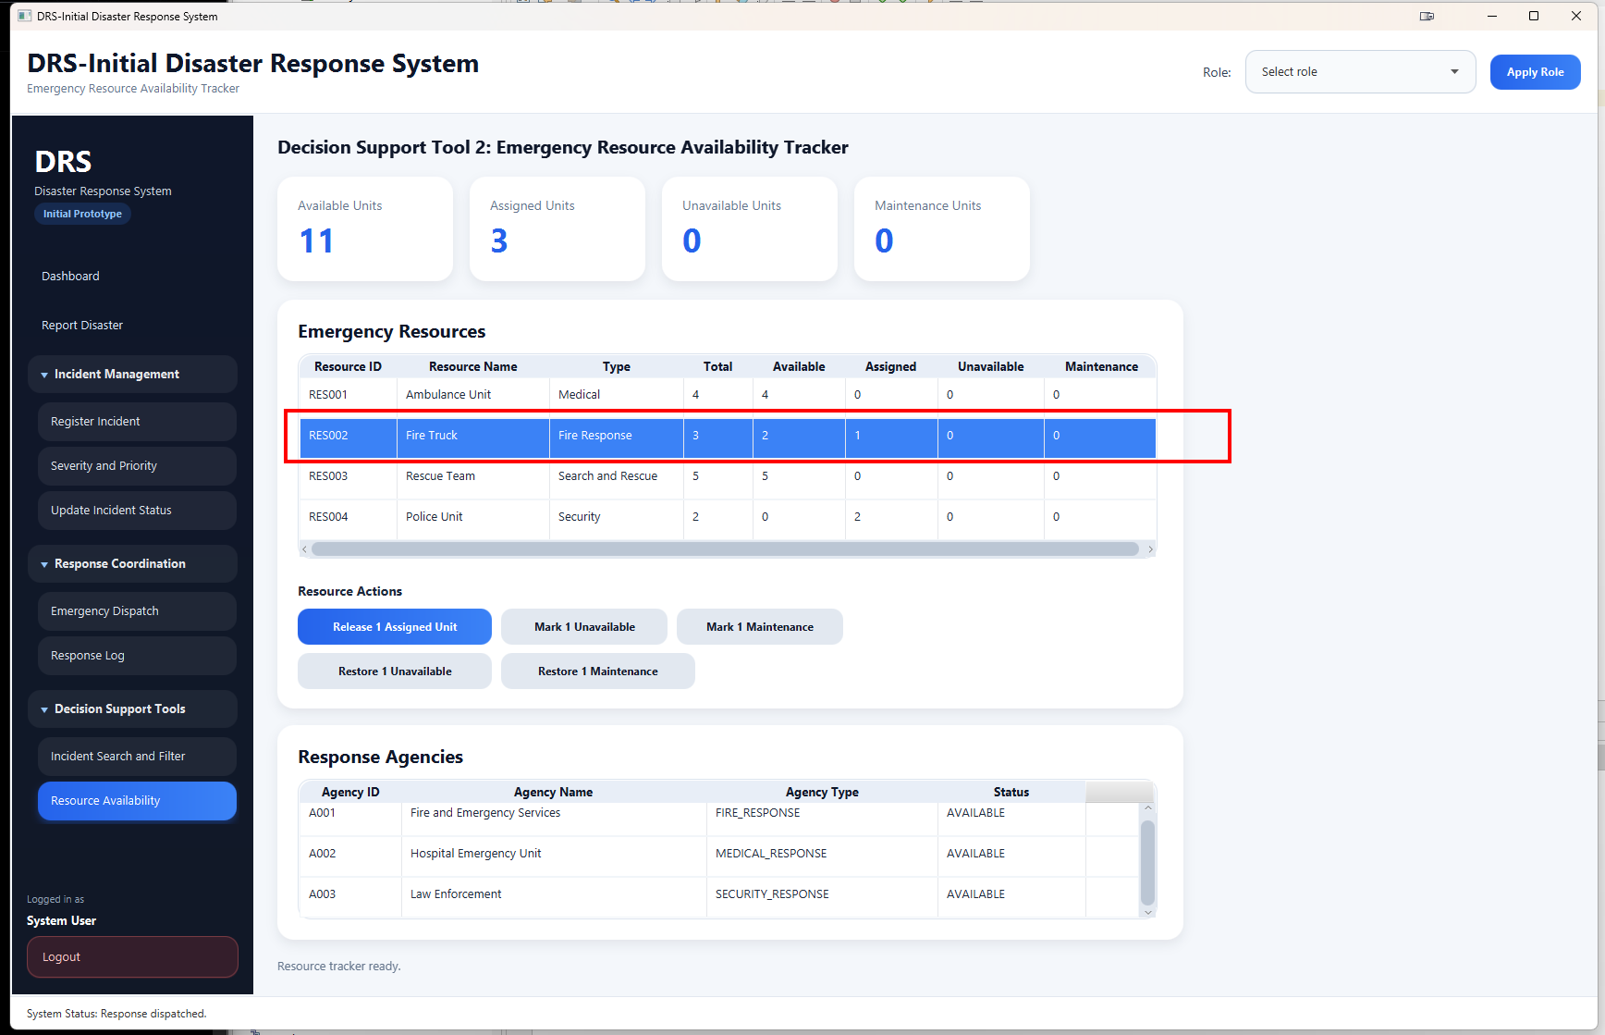
Figure 10: Firetruck Released To Available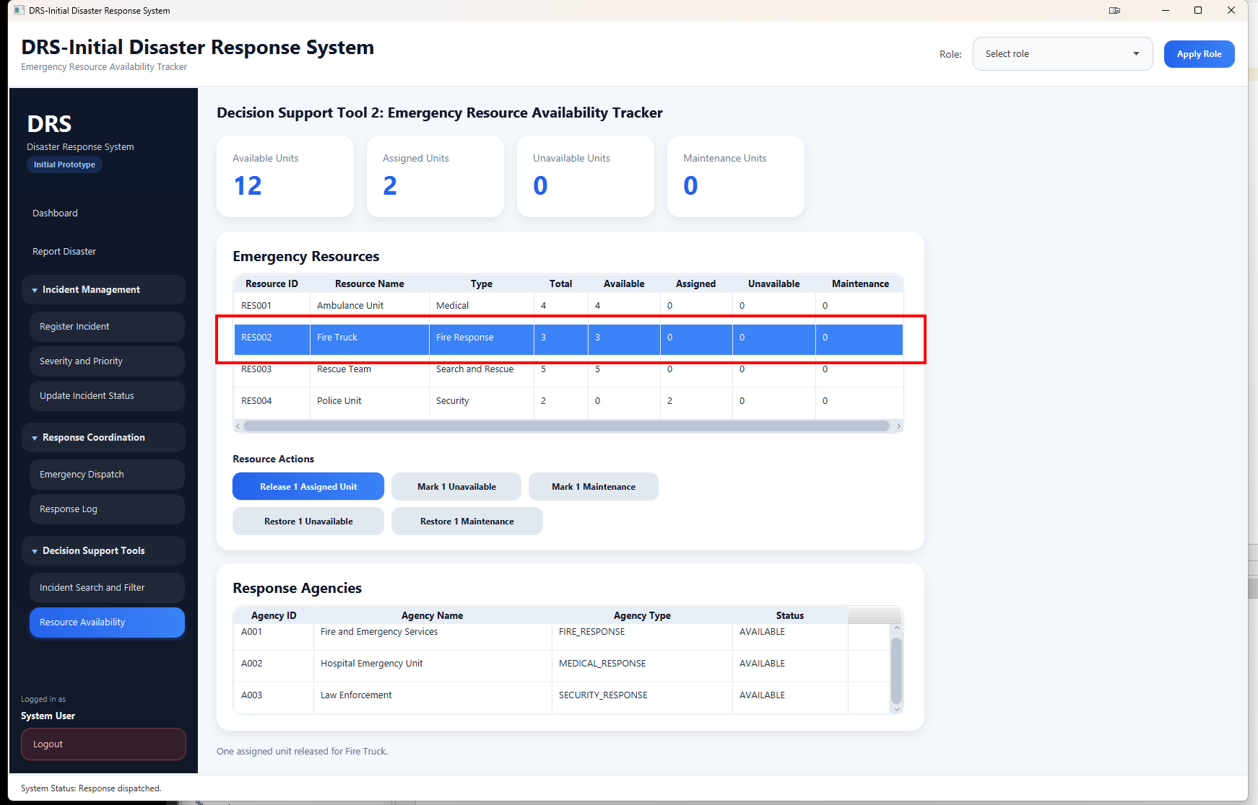

TP21
Figure 11: Resource Status Enum Values
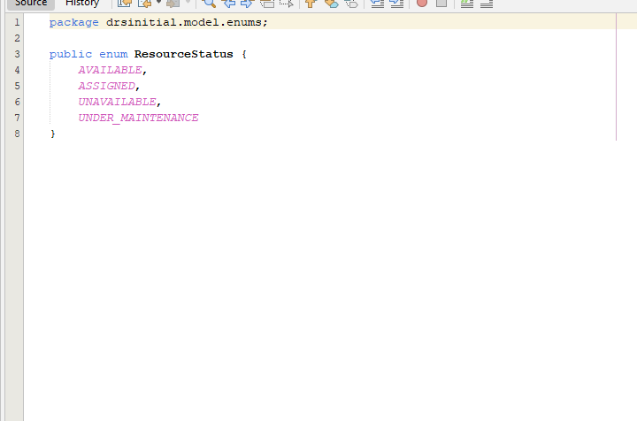

TP22
Figure 12: Report Disaster Submitted
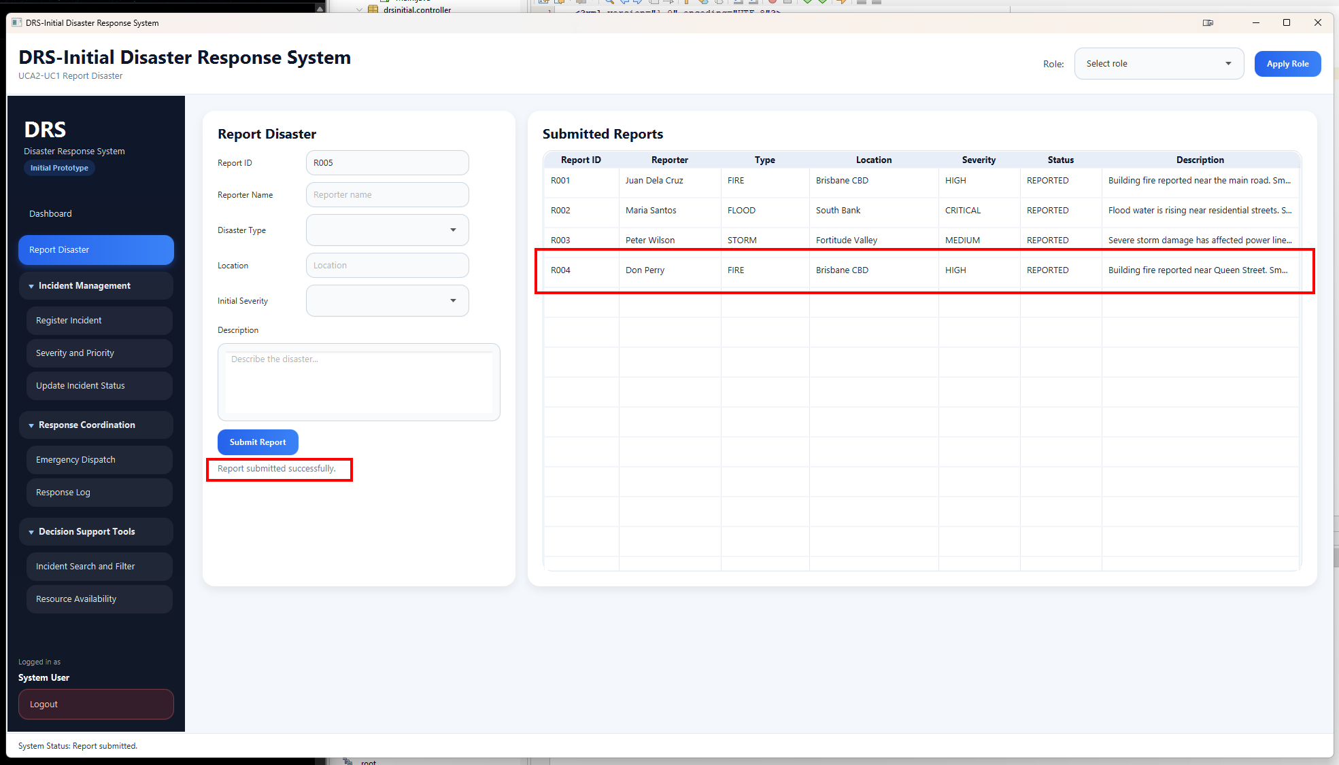

Figure 13: Incident Registered
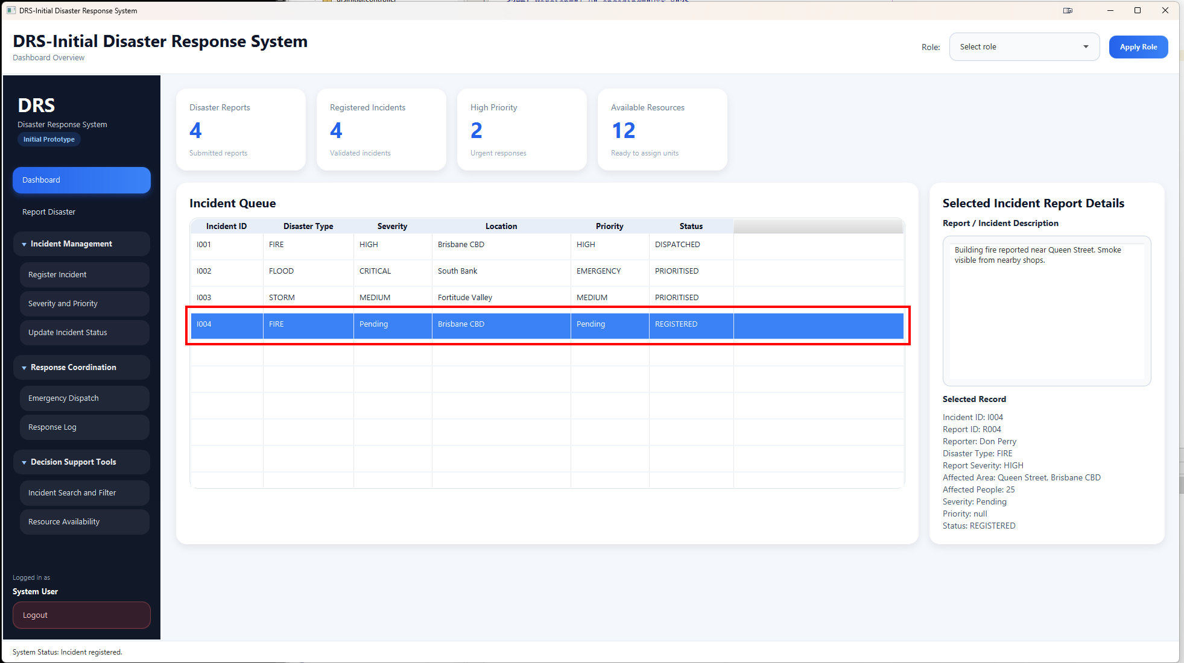

Figure 14: Severity and Priority Assessment Completed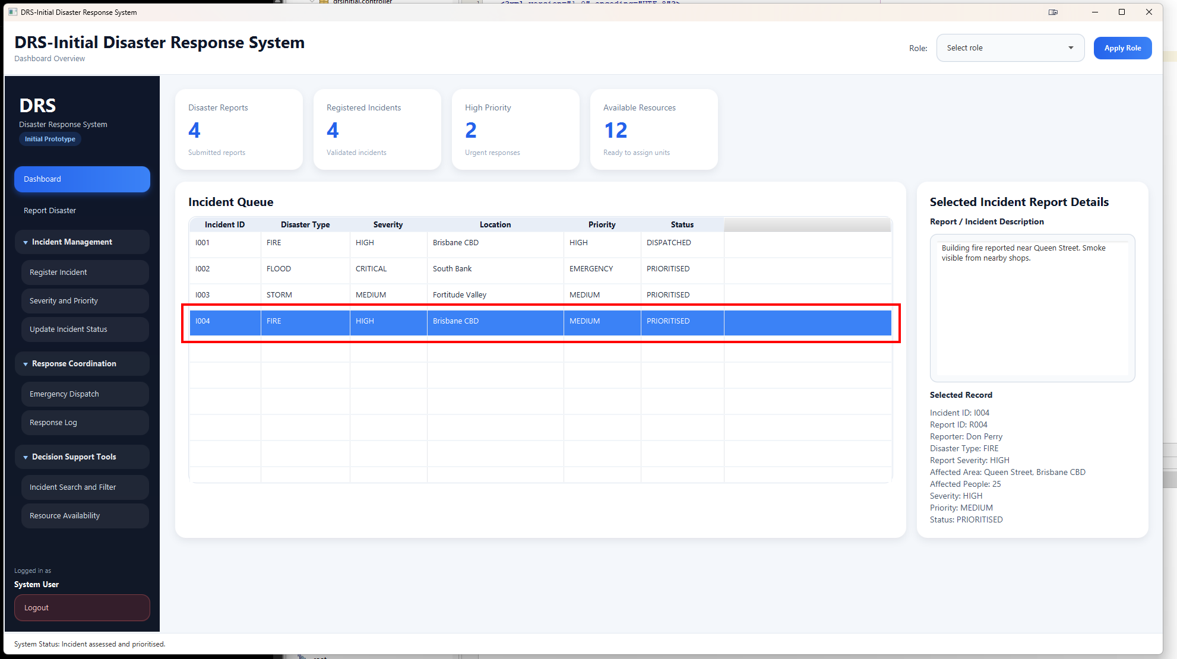

Figure 15: Resource Before Dispatch

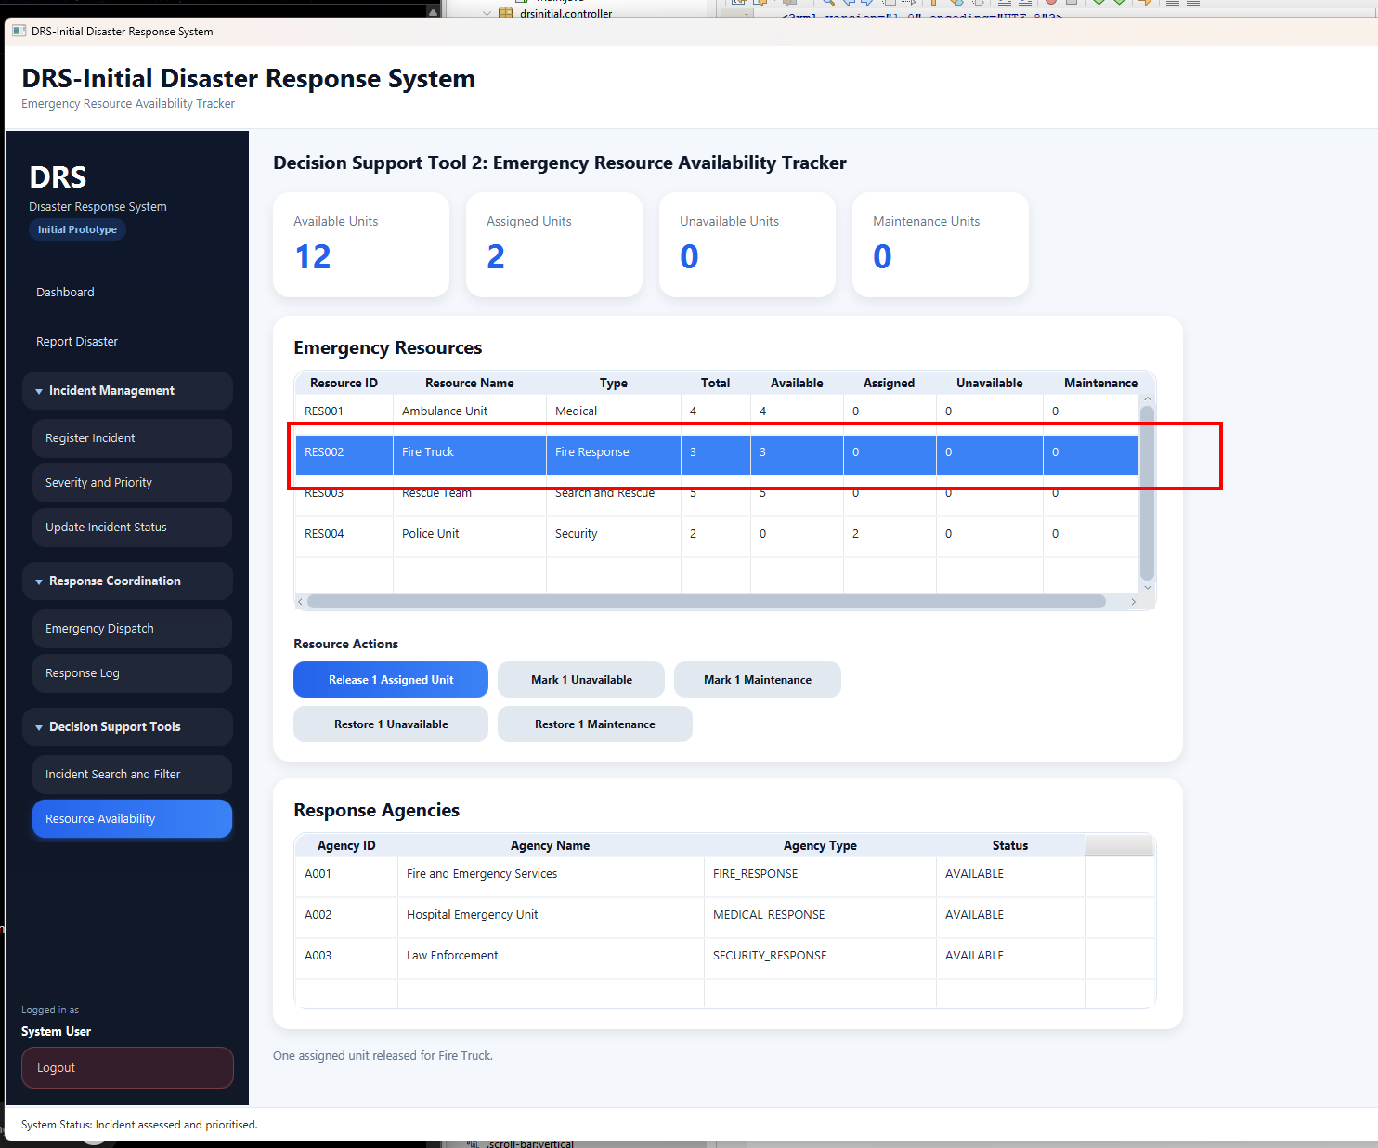
Figure 16: Resource After Dispatch 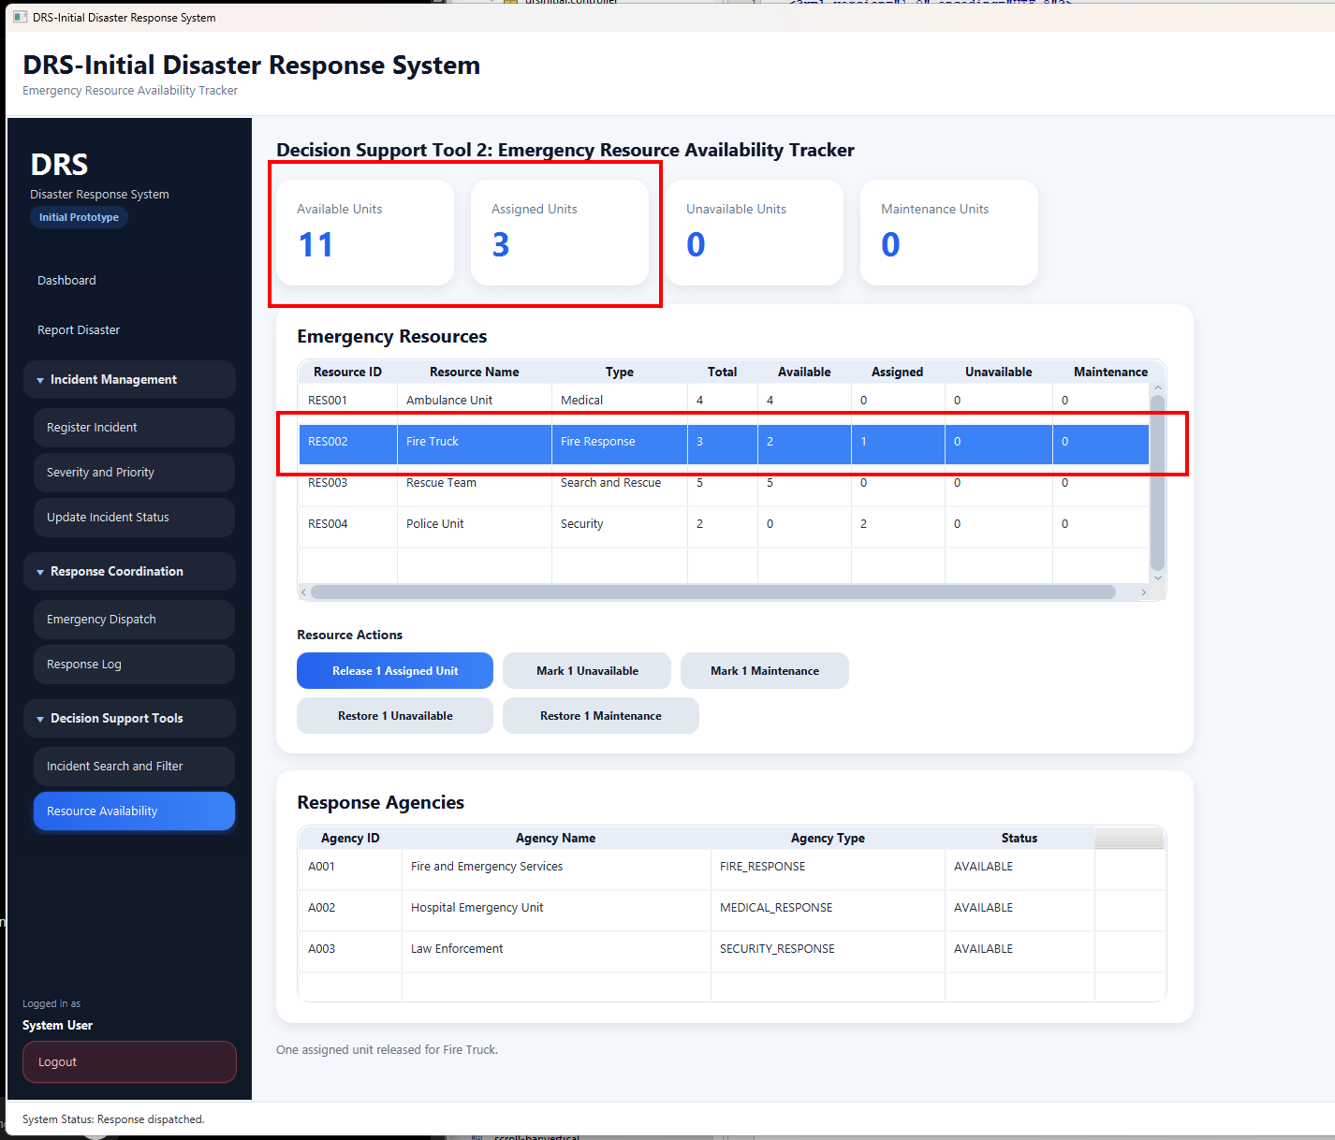
Figure 17: Incident Update Log Dispatch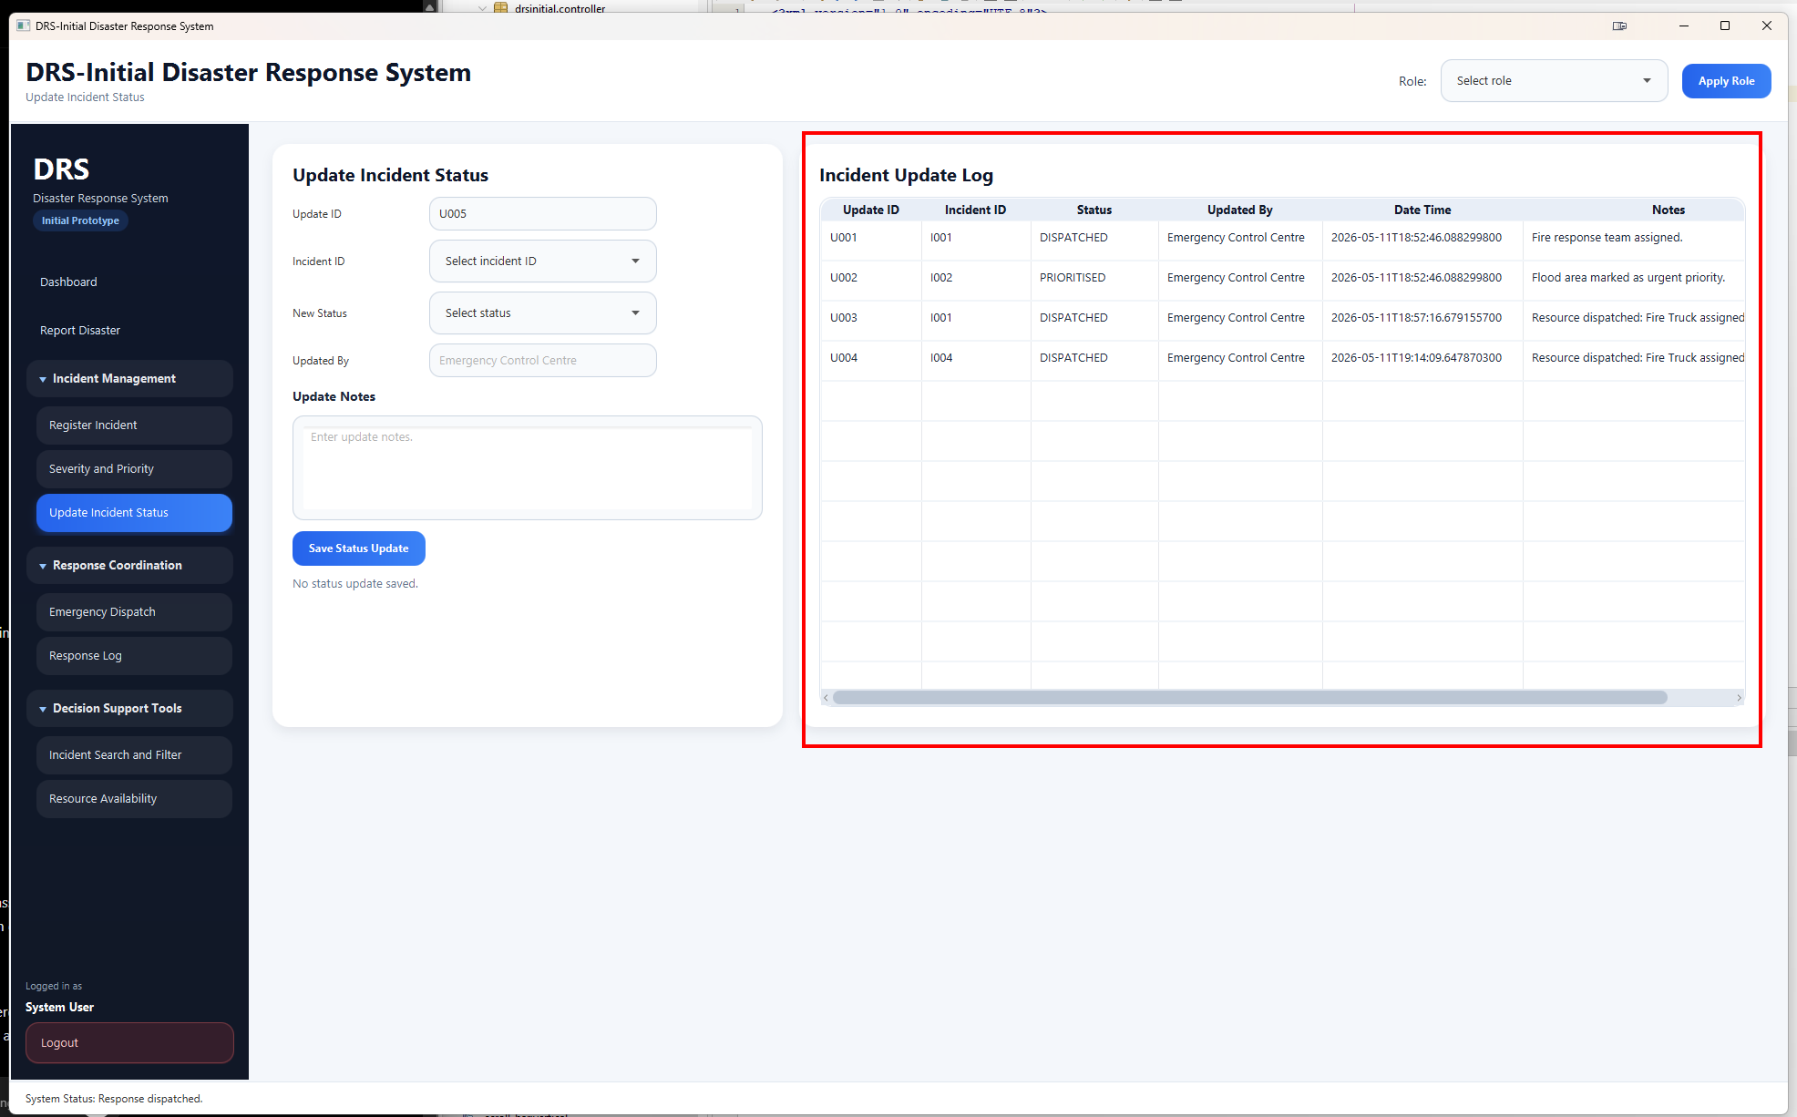
Figure 18: Response Log with Dispatch Time
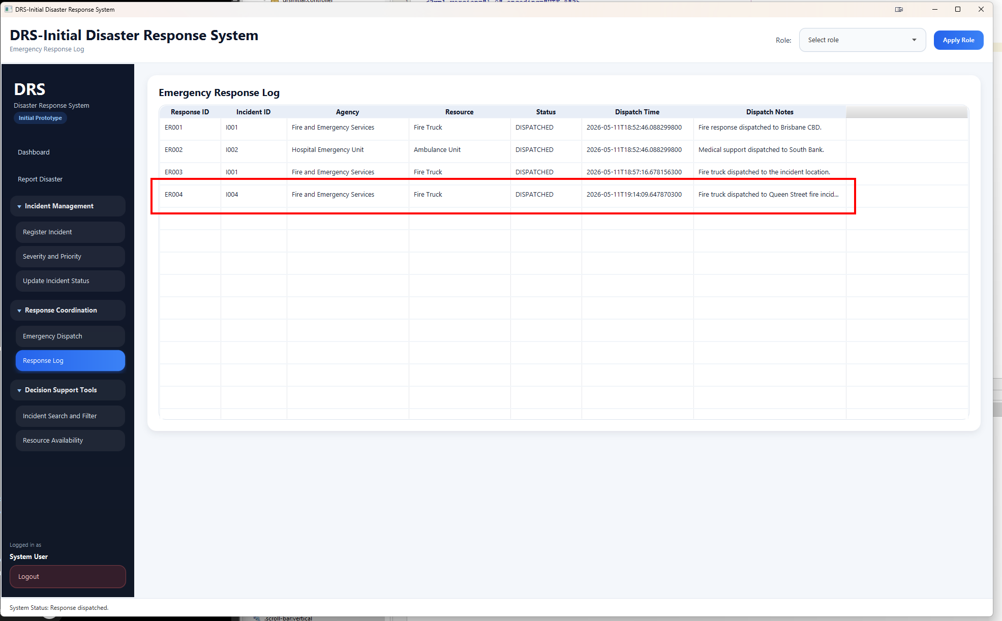

TP23
Figure 19: Incident Queue Before Resolve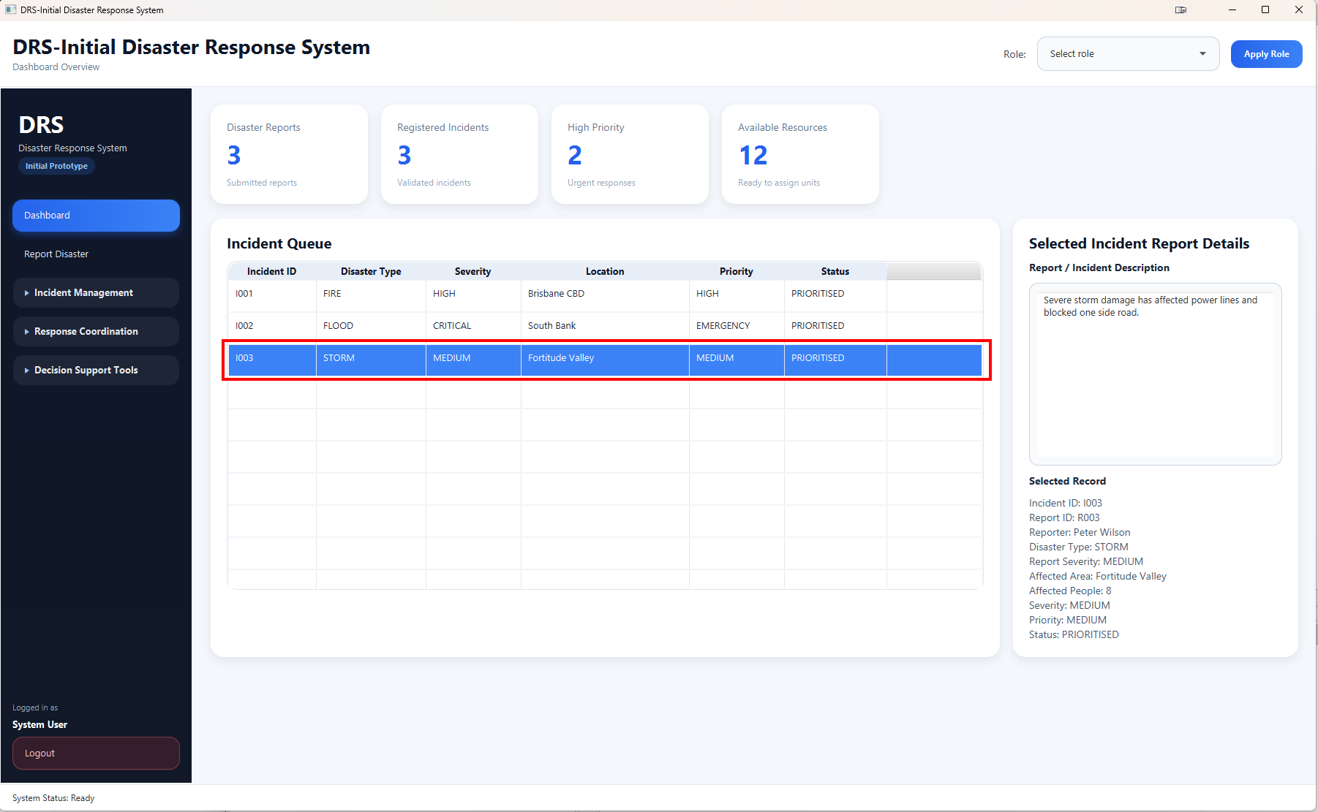
Figure 20: Update Incident Status to Resolve
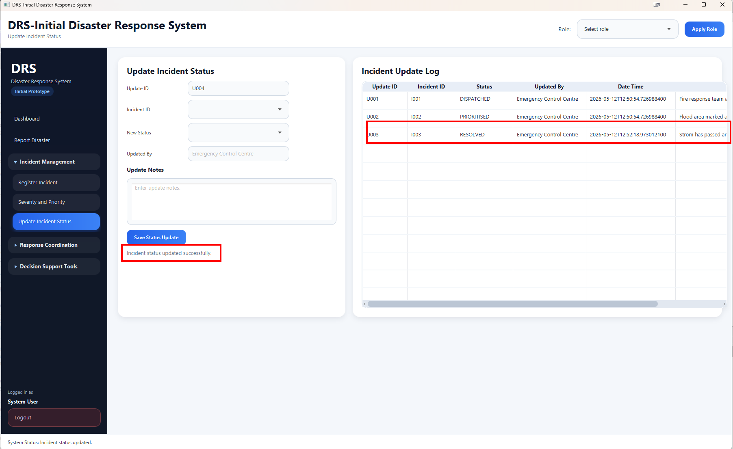
Figure 21: Incident Queue After Resolve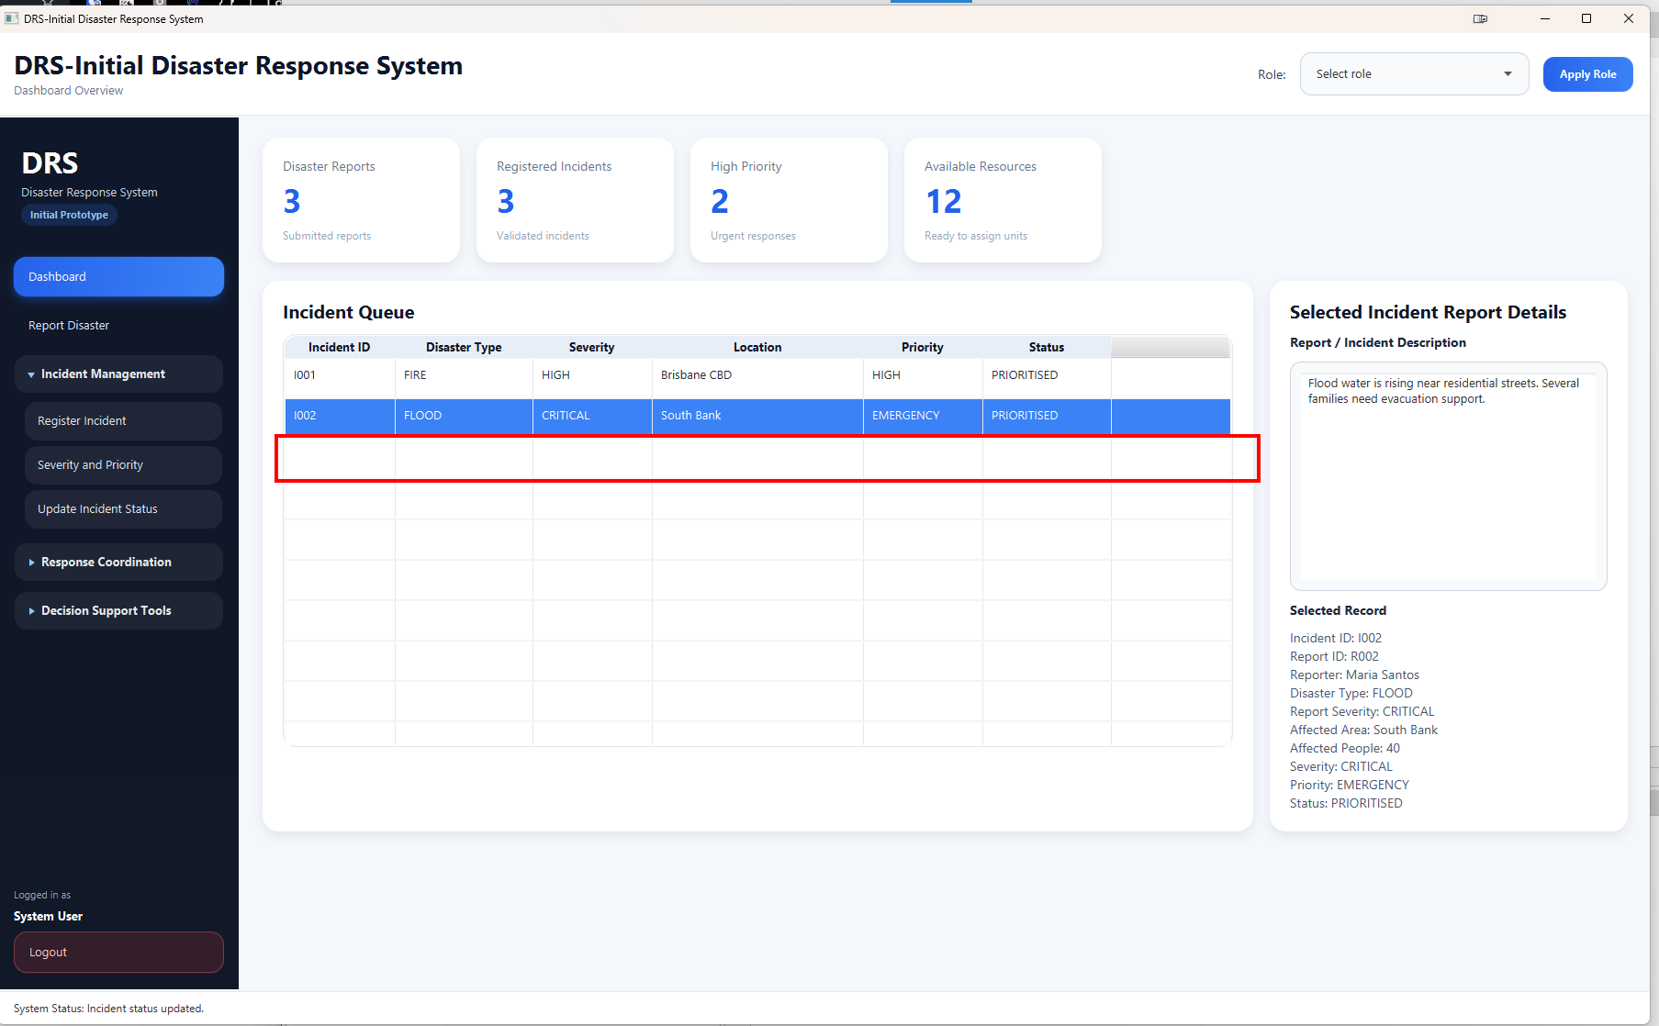

TP24
Figure 22: Incident Search and Filter Keyword Brisbane
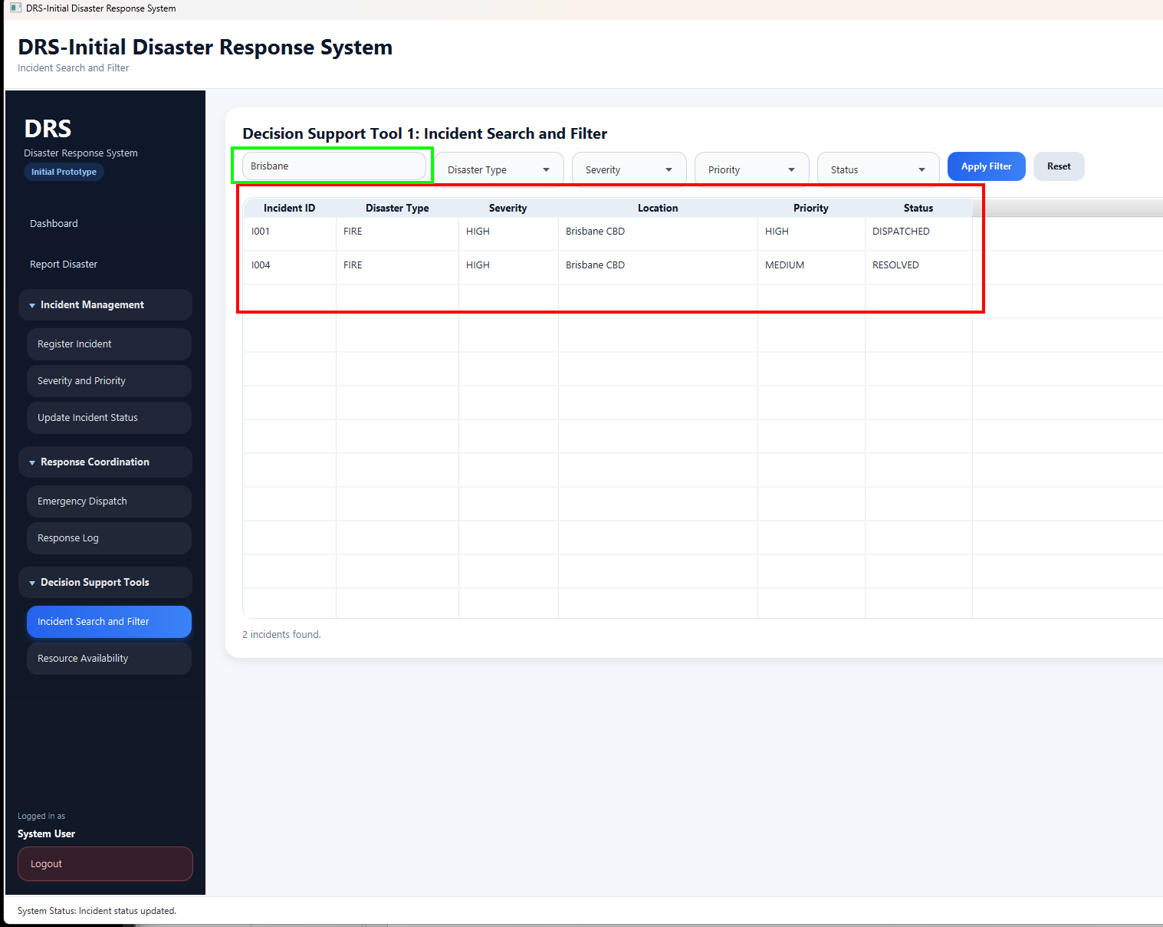

TP25
Figure 23: Incident Search and Filter Disaster Type
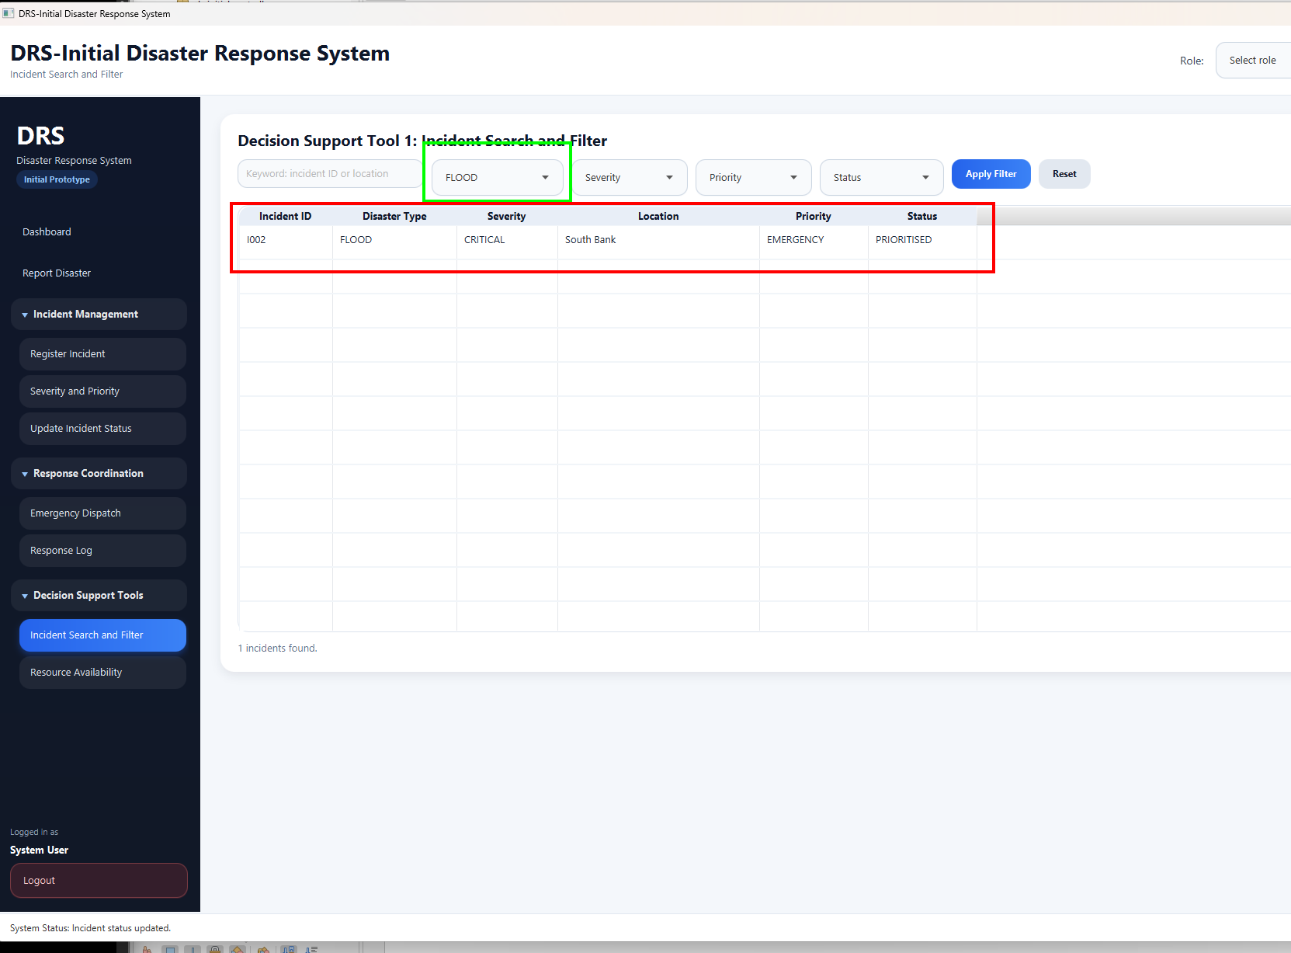

TP26
Figure 24: Incident Search and Filter Severity Type
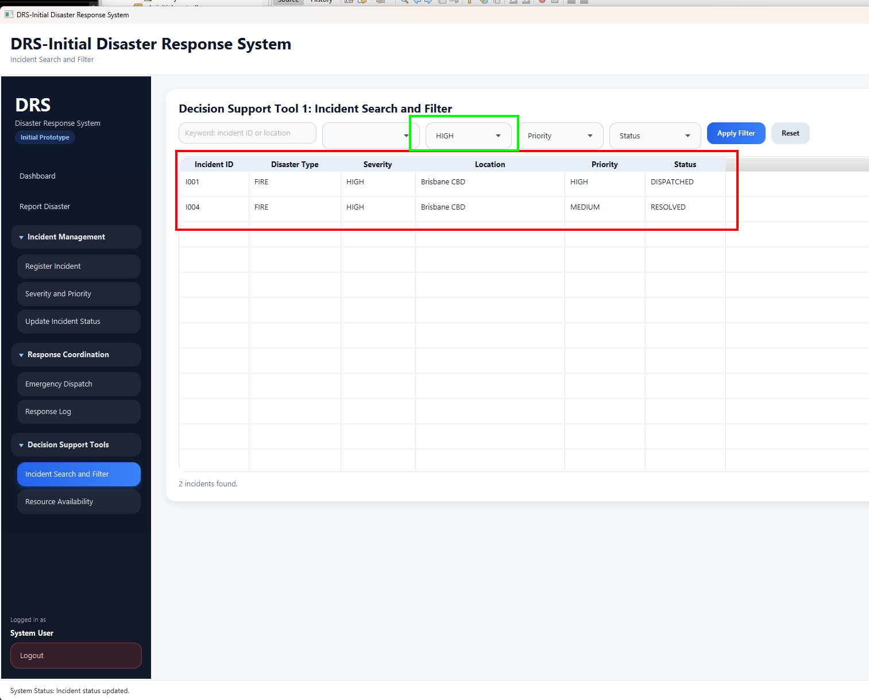

TP27
Figure 25: Incident Search and Filter Priority Type
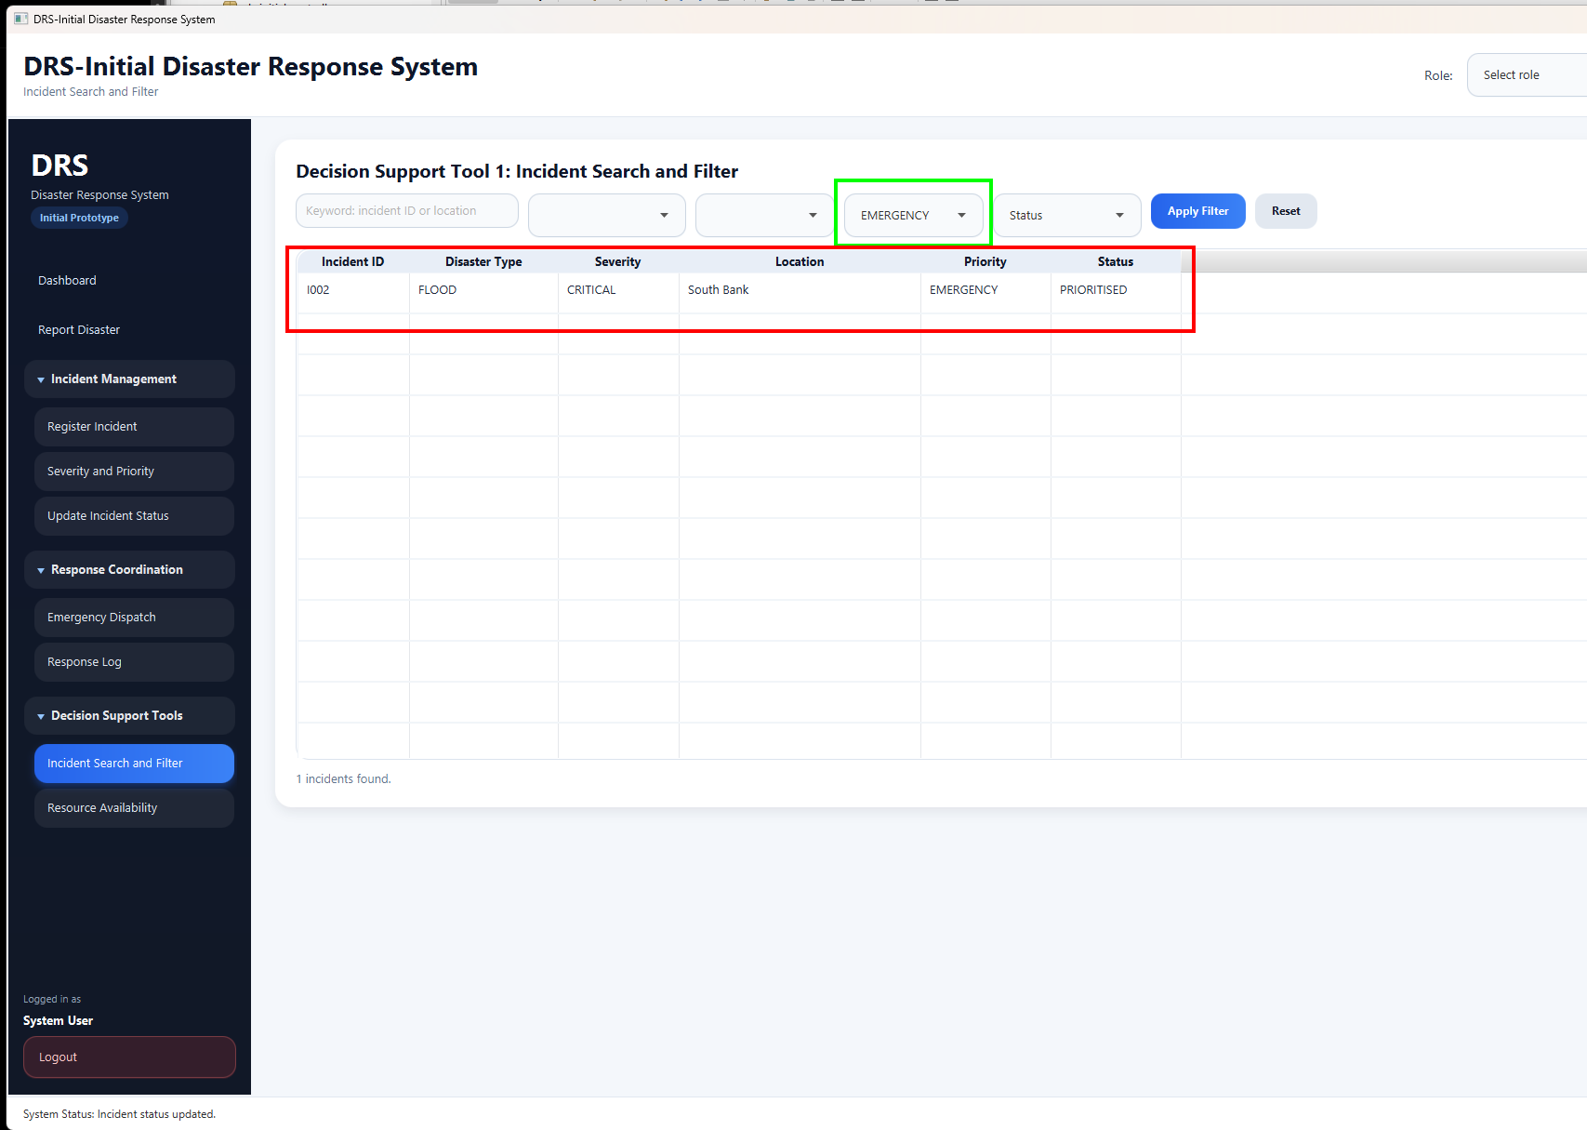

TP28
Figure 26: Incident Search and Filter Status Type
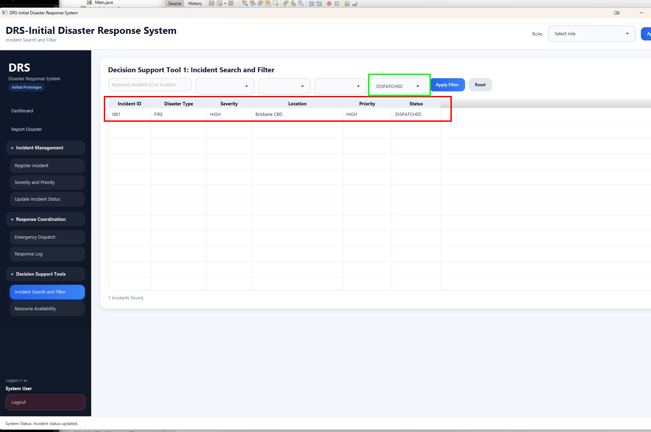

TP29
Figure 27: TP51 Full JUnit Testing for Core Project Logic Evidence
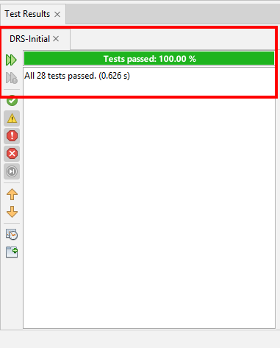

The test results show that the implemented prototype functions were checked against the revised use cases, the two selected creative features, and the core Java logic. All listed test cases passed.

Section 5. Reflection
This section reflects on the revised requirements specification, user interface design, implementation, and testing of the DRS-Initial prototype. Assessment 2 requires reflection on the overall requirements specification, user interface design, and implementation.
5.1 Reflection on Requirements Specification
In revising the Assessment 1 requirements specification, I reduced the original Disaster Response System into a realistic initial prototype. The original system covered a comprehensive disaster management process, covering response, recovery, monitoring, and administration. In Assessment 2, I concentrated on the six UCA2 use cases implemented in DRS-Initial: Report Disaster, Validate/Register Incident, Assess Severity, Prioritize Response, Dispatch Emergency Response, and Update Incident Status.
This allowed me to connect the requirements to the UML class diagram, JavaFX interface, the implementation and the test plan. It also made the prototype score easier to manage and test, since each implemented function was linked to the revised use case. The modified requirements also helped to identify the main data classes by the system, such as DisasterReport, Incident, EmergencyResponse, EmergencyResource, ResponseAgency and IncidentUpdate.
5.2 Reflection on User Interface Design
JavaFX and Scene Builders were used in creating the design for the user interface. This workflow has been designed foe ease of reporting disasters, managing incidents, deploying responses, tracking resources, and filtering incident records.
During development, I improved the layout, sidebar navigation, table visibility, scrollbards, menu labels, and selected menu colours. With these changes the prototype is easer to use and test.
5.3 Reflection on Implementation
The implementation is done using the Model View Controller pattern. This helped in separating the interface, controller actions, model classes, service logic, repository storage and session handling. For the prototype, the ApplicationRepository class, which holds the seeded sample data and in-memory records, was suitable because it allowed the system to run without the database setup.
IncidentService and PriorityRecommendationService classes were used to segregate the business logic from the JavaFX controller. In runtime, the UserSession class has support for simple role selection. This framework also made the project more organized and easier to maintain.
5.4 Reflection on Testing
The test plan helped verify the revised requirements and implemented features. I used manual testing to validate the JavaFX workflow including report submission, incident registration, incident registration, severity assessment, prioritisation, dispatch, status update, resource tracking, and incident filtering.
JUnit4 testing was used to check core java logic, the tested components are model validation, repository storage, service logic, emergency resource availability, user role storage, and priority recommendation. Testing also helped identify wording issues in some test cases, which improved the accuracy of the final test plan. Overall, testing confirmed that the prototype worked as planned and the test data matched the expected results.

5.5 Limitations and Future Improvements
The main limitations are the utilization of seeded sample data, absence of a database, no live hazard data, and no real external agency integration. In a future version, database storage will be added. a stronger role-based access control with login authentication, live hazard data, agency communication, and report generation. These enhancements would render the prototype more akin to a comprehensive Disaster Response System.

Appendices
Appendix A: Revised Use Case Descriptions

UCA2-UC1: Report Disaster
Primary Actor | Public User
Supporting Actor | Emergency Control Centre
Goal | To allow a public user to submit a disaster report through the JavaFX reporting screen.
Prototype Scope | Implemented in the DRS-Initial JavaFX prototype using a separate Report Disaster screen and in-memory application storage.
Preconditions | The application is running.  The user has selected the Public User role.  The Report Disaster screen is available.
Trigger | The user observes a disaster and starts a disaster report.
Main Success Scenario | 1. User opens the Report Disaster screen.  2. System displays the disaster report form.  3. User enters reporter name, disaster type, location, description, date/time, and initial severity.  4. User selects Submit Report.  5. System validates all required fields.  6. System creates a DisasterReport object.  7. System assigns a unique report ID.  8. System saves the report in the application repository.  9. System sets the report status to Reported.  10. System displays a successful submission message.
Alternative Flow | If required fields are missing, the system displays an error message and does not save the report.  If disaster type is not selected, the system asks the user to select a valid disaster type.
Exceptional Flow | If the report cannot be saved, the system displays a save failure message.
Postconditions | A disaster report is saved and ready for validation.
Priority | High

UCA2-UC2: Validate/Register Incident
Primary Actor | Emergency Control Centre
Supporting Actor | Public User
Goal | To validate a submitted disaster report and register it as an official incident.
Prototype Scope | Implemented in the DRS-Initial JavaFX prototype using a separate Validate/Register Incident screen.
Preconditions | The application is running.  The user has selected the Emergency Control Centre role.  At least one disaster report exists with Reported status.
Trigger | The Emergency Control Centre reviews a submitted disaster report.
Main Success Scenario | 1. Emergency Control Centre opens the Validate/Register Incident screen.  2. System displays submitted disaster reports.  3. Emergency Control Centre selects a disaster report.  4. System displays report details.  5. Emergency Control Centre reviews the report information.  6. Emergency Control Centre selects Validate Report.  7. System creates an Incident object from the selected DisasterReport.  8. System assigns a unique incident ID.  9. System sets the incident status to Registered.  10. System saves the incident in the application repository.  11. System displays the registered incident in the incident table.
Alternative Flow | If the report has insufficient information, the Emergency Control Centre marks it as Pending Review.  If the report is invalid, the system updates the report status to Rejected.
Exceptional Flow | If no report is selected, the system displays a message asking the user to select a report.
Postconditions | A valid disaster report becomes a registered incident.
Priority | High

UCA2-UC3: Assess Severity
Primary Actor | Emergency Control Centre
Supporting Actor | Simulated Hazard Data
Goal | To assess the severity of a registered incident and support response planning.
Prototype Scope | Implemented in the DRS-Initial JavaFX prototype using a separate Assess Severity screen. Includes Incident Priority Recommendation System.
Preconditions | The application is running.  The user has selected the Emergency Control Centre role.  An incident exists with Registered status.
Trigger | The Emergency Control Centre starts severity assessment.
Main Success Scenario | 1. Emergency Control Centre opens the Assess Severity screen.  2. System displays registered incidents.  3. Emergency Control Centre selects an incident.  4. System displays incident details.  5. Emergency Control Centre enters affected people, affected area, hazard level, and severity level.  6. System validates the assessment data.  7. System records the severity level.  8. System suggests a priority level.  9. System displays the recommended priority.  10. Emergency Control Centre saves the assessment.  11. System updates the incident status to Assessed.
Alternative Flow | If assessment data is incomplete, the system displays a validation message.
Exceptional Flow | If no incident is selected, the system displays a message asking the user to select an incident.
Postconditions | The incident has an assigned severity level and suggested priority.
Priority | High

UCA2-UC4: Prioritize Response
Primary Actor | Emergency Control Centre
Supporting Actor | Fire and Emergency Services, Hospital, Law Enforcement
Goal | To confirm or adjust the response priority of an assessed incident.
Prototype Scope | Implemented in the DRS-Initial JavaFX prototype using a separate Prioritize Response screen.
Preconditions | The application is running.  The user has selected the Emergency Control Centre role.  An incident exists with Assessed status.
Trigger | The Emergency Control Centre prepares the incident for response planning.
Main Success Scenario | 1. Emergency Control Centre opens the Prioritize Response screen.  2. System displays assessed incidents.  3. Emergency Control Centre selects an incident.  4. System displays severity and recommended priority.  5. Emergency Control Centre reviews the recommendation.  6. Emergency Control Centre confirms or adjusts the priority.  7. System records the final priority.  8. System updates the incident status to Prioritized.
Alternative Flow | If the incident has no severity level, the system asks the user to complete severity assessment first.
Exceptional Flow | If no incident is selected, the system displays a message asking the user to select an incident.
Postconditions | The incident has a confirmed response priority.
Priority | High

UCA2-UC6: Dispatch Emergency Response
Primary Actor | Emergency Control Centre
Supporting Actor | Simulated Response Agency
Goal | To dispatch a response agency and assign resources to a prioritized incident.
Prototype Scope | Implemented in the DRS-Initial JavaFX prototype using a separate Dispatch Response screen. Includes Emergency Resource Availability Tracker.
Preconditions | The application is running.  The user has selected the Emergency Control Centre role.  An incident exists with Prioritized status.
Trigger | The Emergency Control Centre dispatches response support.
Main Success Scenario | 1. Emergency Control Centre opens the Dispatch Response screen.  2. System displays prioritized incidents.  3. Emergency Control Centre selects an incident.  4. System displays agencies and resource counters.  5. System shows resource statuses.  6. Emergency Control Centre selects an agency and resource type.  7. Emergency Control Centre dispatches resources.  8. System updates the resource counter.  9. System updates the incident status to Dispatched.
Alternative Flow | If selected resources are unavailable, the system asks the user to select another resource.
Exceptional Flow | If no incident is selected, the system displays a message asking the user to select an incident.
Postconditions | A response agency and resource are assigned to the incident.
Priority | High

UCA2-UC12: Update Incident Status
Primary Actor | Emergency Control Centre
Supporting Actor | Simulated Response Agency
Goal | To update an active incident and search or filter incident records.
Prototype Scope | Implemented in the DRS-Initial JavaFX prototype using a separate Update Incident Status screen. Includes Incident Search and Filter.
Preconditions | The application is running.  The user has selected the Emergency Control Centre role.  At least one incident exists.
Trigger | The Emergency Control Centre receives progress information or searches for an incident.
Main Success Scenario | 1. Emergency Control Centre opens the Update Incident Status screen.  2. System displays all incidents.  3. Emergency Control Centre searches or filters incidents.  4. System displays matching records.  5. Emergency Control Centre selects an incident.  6. Emergency Control Centre updates the status.  7. System validates the update.  8. System saves the update.  9. System displays the updated status.
Alternative Flow | If no matching records are found, the system displays an empty result message.
Exceptional Flow | If no incident is selected, the system displays a message asking the user to select an incident.
Postconditions | The incident record shows the latest status and update history.
Priority | High

Appendix B: Revised Use Case Diagram
